Emre Can Şen- 21902516

Section-2

Lab-02

Analytical Part

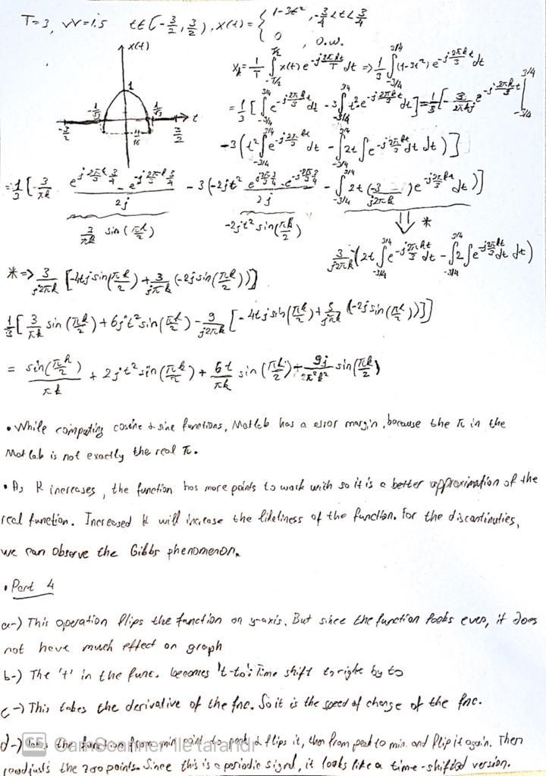

Part 1

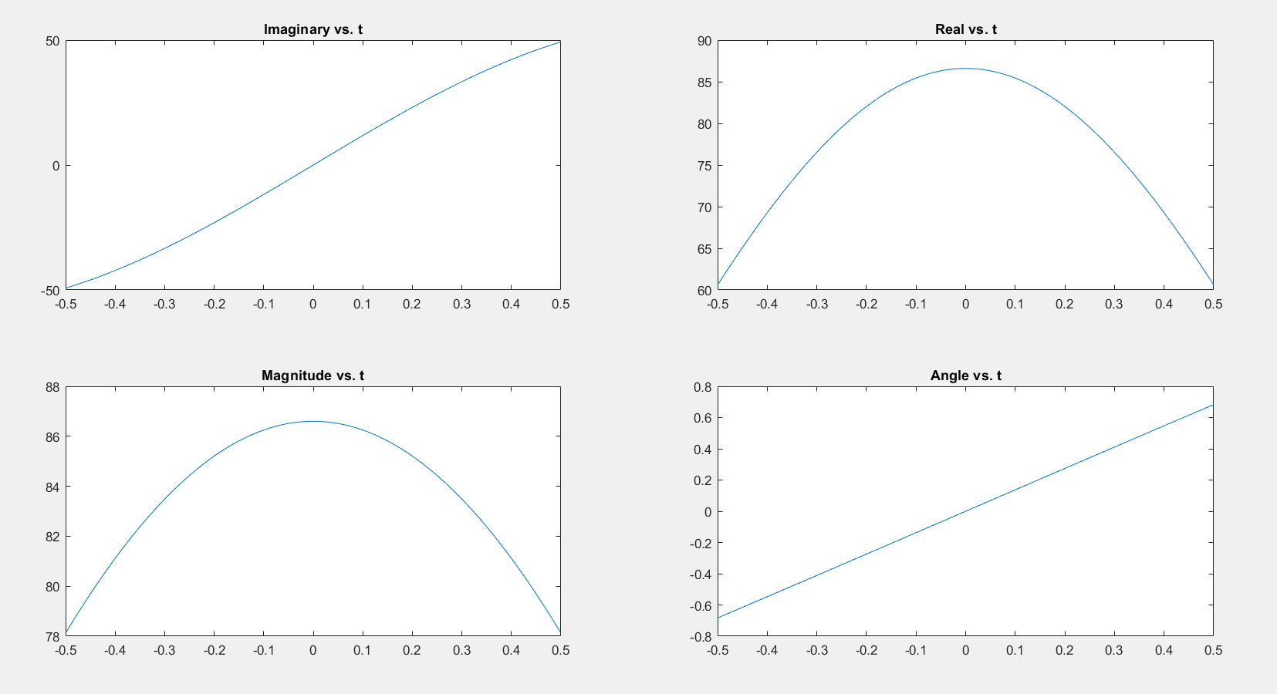

Figure 1- SUMCS Output

Part 3

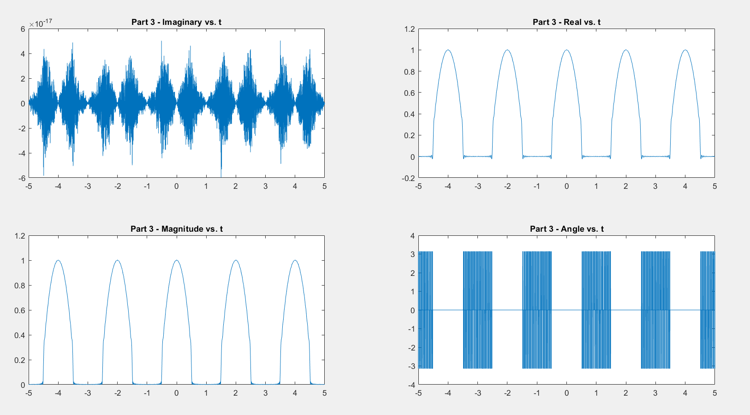

Figure 2- FSWave Output

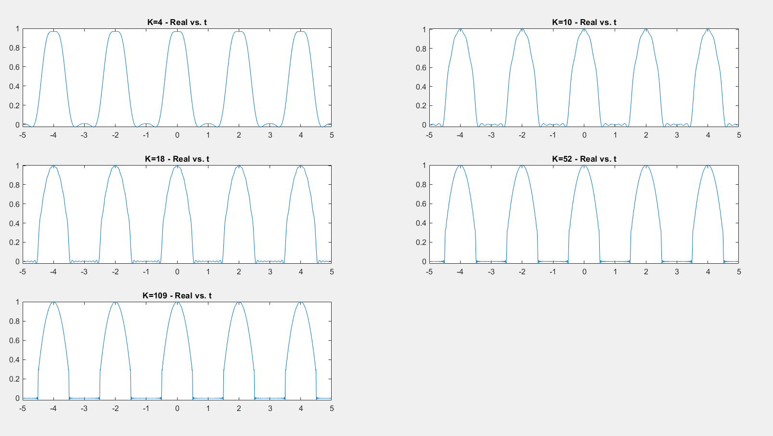

Figure 3- FSWave Output for Differing K’s

Part 4

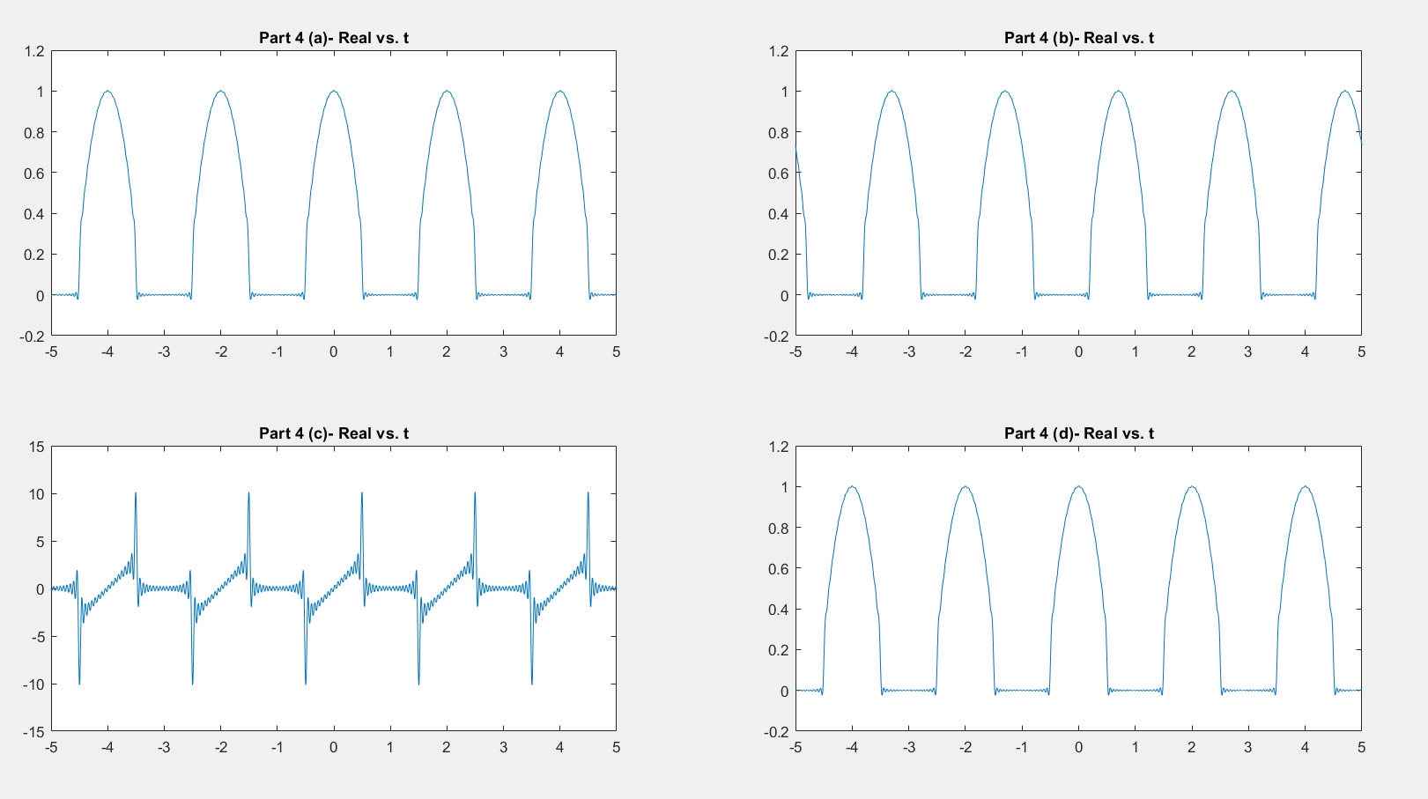

Figure 4- Part 4 Output

MATLAB Code

t=[-0.5:0.001:0.5];

t3=[-5:0.001:5];

t4=[-5:0.001:5];

t4b=[-5:0.001:5]-0.7;

A=1+(4).\*rand(1,33);

omega=pi.\*rand(1,33);

K=37;

K1=4;

K2=10;

K3=18;

K4=52;

K5=109;

K6=34;

T=2;

W=1;

x1=SUMCS(t,A,omega);

x2=FSWave(t3,K,T,W);

x3=FSWave(t4,K1,T,W);

x4=FSWave(t4,K2,T,W);

x5=FSWave(t4,K3,T,W);

x6=FSWave(t4,K4,T,W);

x7=FSWave(t4,K5,T,W);

x8=FSWave(-t4,K6,T,W);

xb=FSWave(t4b,K6,T,W);

xc=FS1Wave(t4,K6,T,W);

xd=FS2Wave(t4,K6,T,W);

figure(1)

subplot(2,2,1);

plot(t,imag(x1))

title('Imaginary vs. t')

subplot(2,2,2);

plot(t,real(x1))

title('Real vs. t')

subplot(2,2,3);

plot(t,abs(x1))

title('Magnitude vs. t')

%((imag(x1)).^2+(real(x1)).^2).^(1/2)

subplot(2,2,4);

plot(t,angle(x1))

title('Angle vs. t')

figure(2)

subplot(2,2,1);

plot(t3,imag(x2))

title('Part 2 - Imaginary vs. t')

subplot(2,2,2);

plot(t3,real(x2)),

title('Part 2 - Real vs. t')

subplot(2,2,3);

plot(t3,abs(x2))

title('Part 2 - Magnitude vs. t')

subplot(2,2,4);

plot(t3,angle(x2))

title('Part 2 - Angle vs. t')

figure(3)

subplot(3,2,1);

plot(t4,real(x3))

title('K=4 - Real vs. t')

subplot(3,2,2);

plot(t4,real(x4))

title('K=10 - Real vs. t')

subplot(3,2,3);

plot(t4,real(x5))

title('K=18 - Real vs. t')

subplot(3,2,4);

plot(t4,real(x6))

title('K=52 - Real vs. t')

subplot(3,2,5);

plot(t4,real(x7))

title('K=109 - Real vs. t')

figure(4)

subplot(2,2,1)

plot(t4,real(x8))

title('Part 4 (a)- Real vs. t')

subplot(2,2,2)

plot(t4,real(xb))

title('Part 4 (b)- Real vs. t')

subplot(2,2,3)

plot(t4,real(xc))

title('Part 4 (c)- Real vs. t')

subplot(2,2,4)

plot(t4,real(xd))

title('Part 4 (d)- Real vs. t')

function xs = SUMCS(t,A,omega)

xs=zeros(1,length(t));

for i=1:length(omega)

xs= xs+A(i)\*exp(1j\*omega(i)\*t);

end

end

function xt= FSWave(t,K,T,W)

k0=[-K:K];

fun=@(x) exp(-1j\*2\*pi/T\*k0\*x).\*(1-3\*x.^2);

xk=1/T\*integral(fun,-W/2, W/2,'ArrayValued',true);

xt=SUMCS(t,xk,2\*pi\*k0/T);

end

function xt= FS1Wave(t,K,T,W)

k0=[-K:K];

fun=@(x) exp(-1j\*2\*pi/T\*k0\*x).\*(1-3\*x.^2);

xkz=1/T\*integral(fun,-W/2, W/2,'ArrayValued',true);

xk=(-1j\*2\*pi/T\*k0).\*xkz;

xt=SUMCS(t,xk,2\*pi\*k0/T);

end

function xt= FS2Wave(t,K,T,W)

k1=[-K:-1];

k2=[1:K];

k1=flip(k1);

k2=flip(k2);

k0=[k1 0 k2];

fun=@(x) exp(-1j\*2\*pi/T\*k0\*x).\*(1-3\*x.^2);

xk=1/T\*integral(fun,-W/2, W/2,'ArrayValued',true);

xt=SUMCS(t,xk,2\*pi\*k0/T);

end